**Sample Fabric Git Code Deployment & Run Screen Shot**

1. This is starting of ./runApp for the balance-transfer hyperledger script.

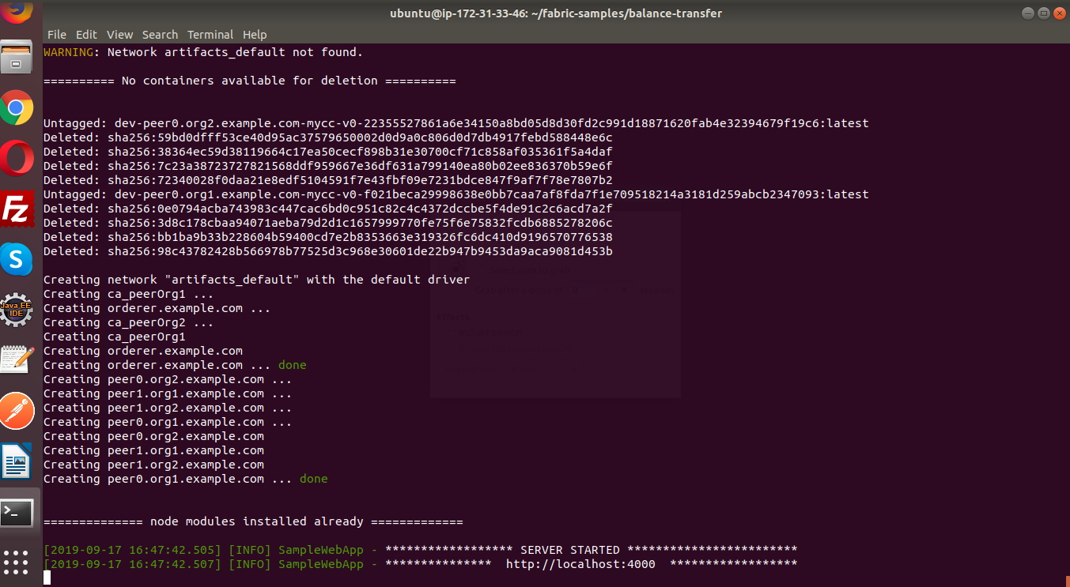

1. This is the start of testAPI script for balance-transfer code.

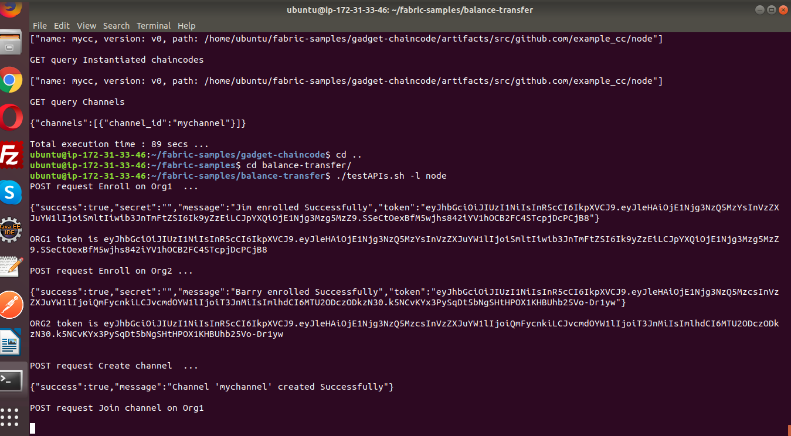

1. This is the execution of APIs for the chaincode calls on balance-transfer smart contract (testAPI).

